

**Ankara Yıldırım Beyazıt University**

**MIS204 Project Assignment**

**WRISTBANDAPP DATABASE MANAGEMENT SYSTEM**

**Project Members**

1-) Muhammet Ali AMANVERMEZ – 19030411007

2-) Serdar YILDIZ -19030411010

3-) Meryem Kevser EMİR - 19030411038

4-) Yunus Emre ULUSAN - 19030411029

5-) Ersel DİNÇKAYA - 19030411045

Table Of Contents

Wristband Database Management System……………..1

Table Of Contents……………………………………………………2

Report …………………………………………………………………….3

Business Rules ………………………………………………………..4

ER Model…………………………………………………………………5

ERM Model……………………………………………………………..5

Relationship Schemas……………………………………………..6

NF Transformation………………………………………………….7

Table Output Code………………………………………………….8

SQL Queries…………………………………………………………..12

Data Dictionary………………………………………………………22

**DATA REPORT**

**The pandemic we have been in since March 2020 has affected all humanity in every way. Based on this situation, we designed an integrated wristband with a mobile app to control the spread of the pandemic. Thanks to this application, which we call WRISTBANDAPP, and its integrated database, we aimed to get location and status information for COVID-19 patients and their contacts who are wearing wristbands by the relevant hospitals within a certain period of time.**

**First of all, we decided to set the business rules when starting the project. In these business rules , we have stated the main limits of the documents and data that we have created, we have established rules. The project, which works under these rules, has certain tables and dictionaries. The ER model sets the properties of objects by establishing relationships between database objects to be created.There are 3 basic concepts in an ER model. These concepts are entity, attribute, and Relationship. In relationship diagrams, we wanted to show the relationships between tables in a regular format and connect the key points. In NF tables, we wanted to eliminate data repeats in the database and increase data consistency (accuracy) by keeping foreign keys at the forefront. We have prepared output codes for tables created to show tables and data types using MS SQL. Considering the objectives of the project, we thought about the most useful and necessary queries and implemented them according to the need. In these queries, we collected the necessary data together, taking into account the relationships between tables, and met the needs of users. We designed a data dictionary with type , format and abbreviations.**

**In short, within the scope of the project, a wristband database management system was studied. In this context, the importance of designing wristband database system was first mentioned and diagrams and tables were drawn based on Business Rules. Then, ER diagrams are drawn, components, NF tables, data dictionaries, relationship diagrams are drawn, and the necessary SQL operations are encoded using MS SQL. Finally, the results were written and the project was completed.**

**(In revealing this assignment, we gathered every day between 22:00 and 23:59 in the evening with the participation and contribution of all group members. Each stage of the assignment took place with the participation of all group members , group work and solidarity rather than individuality are at the forefront.)**

**BUSINESS RULES**

**1-)** The employees in the hospital: doctors, nurses, cleaners, security guards, directors, secretaries.

**2-)** The hospital_id , region_id, wristband_id are recorded in the hospital management system.

**3-)** Every hospital has a certain number of wristbands.

**4-)** There must be more than one hospital in each region.

**5-)** Each hospital can belong to only one region.

**6-)** A wristband can only belong to a hospital.

**7-)** There may be a mutation in a patient. There can be not more than one mutation.

**8-)** There are 5 different types of mutations in total. These are British, Chinese, Brazilian, South African, Indian.

**9-)** Each bracelet color shows the patient's situation.

**10-)** There are 3 colors in the bracelet. Red: sick, yellow: contacted, green represents healthy individuals.

**11-)** HES Code and wristband id are linked to each other.

**12-)** There are 7 regions in the regions table.

**13-)** Each patient's name, surname, region, hospital, variant type, wristband color, examination date and HES code are registered in the system.

**14-)** The wristband cannot be removed from the wrist during the quarantine period (14 days).

**15-)** Hes codes must be 12 digits. (12 characters including hyphens) For example: "ERS7-4P5T-72".

**16-)** Regions are divided into four as Risky, Medium Risk, Low Risk and Safe according to the Covid risk group based on the number of sick people they host.

**17-)** The location and the status of the bracelet are obtained from the user of the bracelet.

**ER MODEL**

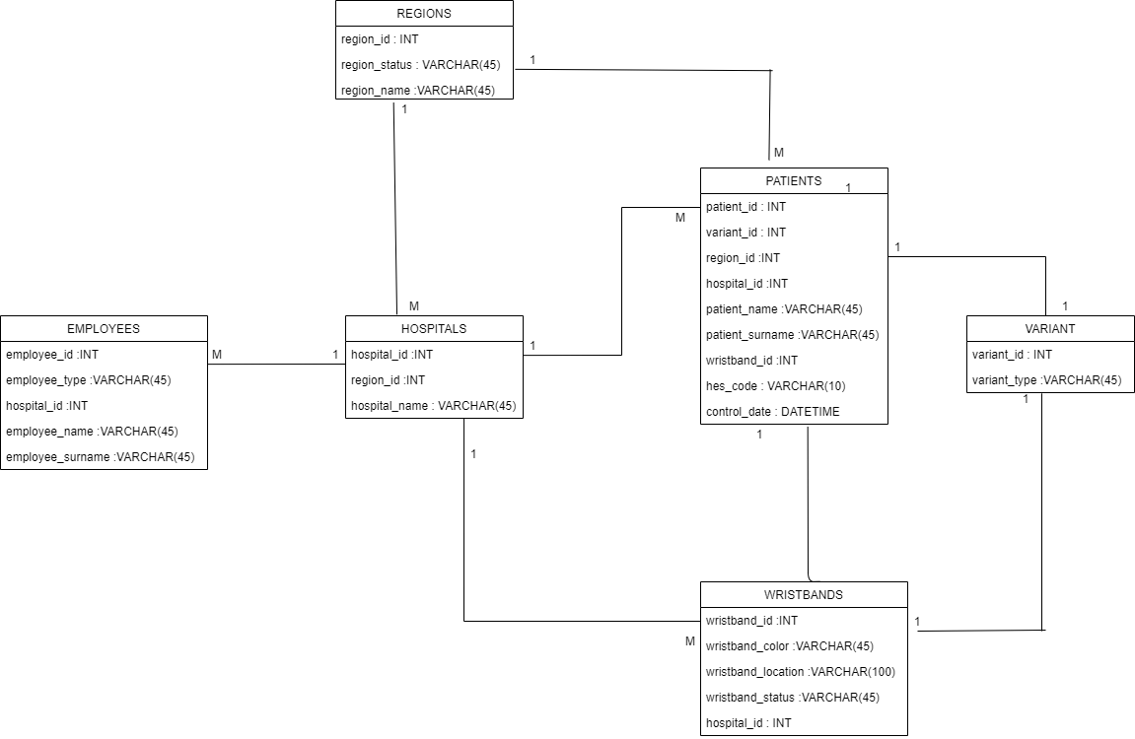

**ERM MODEL**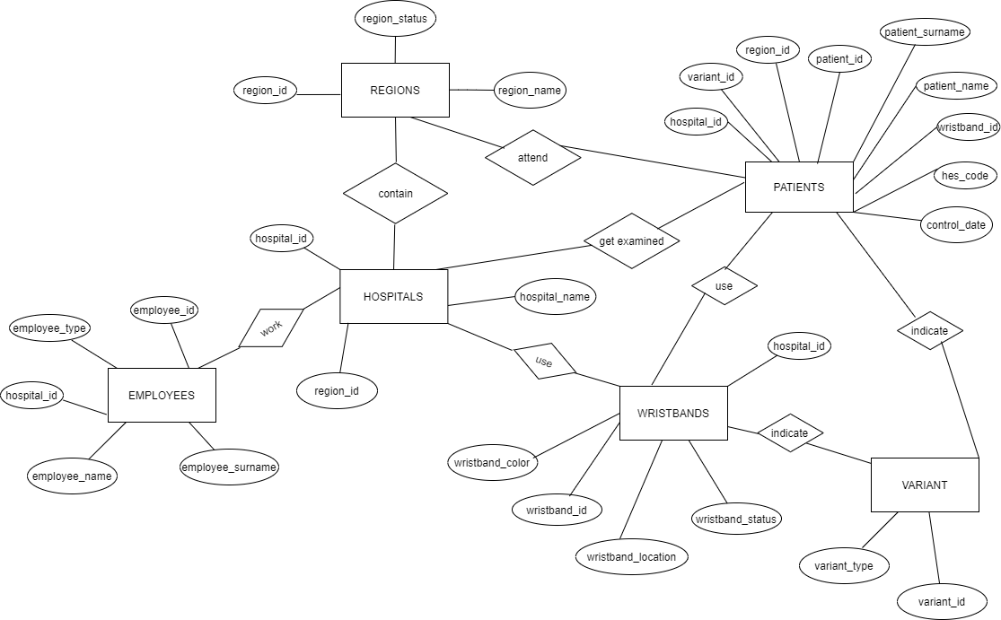

**Relationship Schema**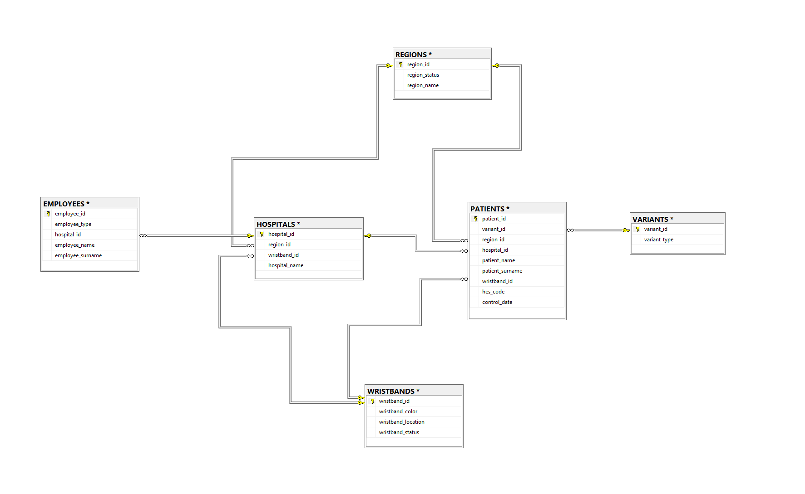

**Relationship Schema 2**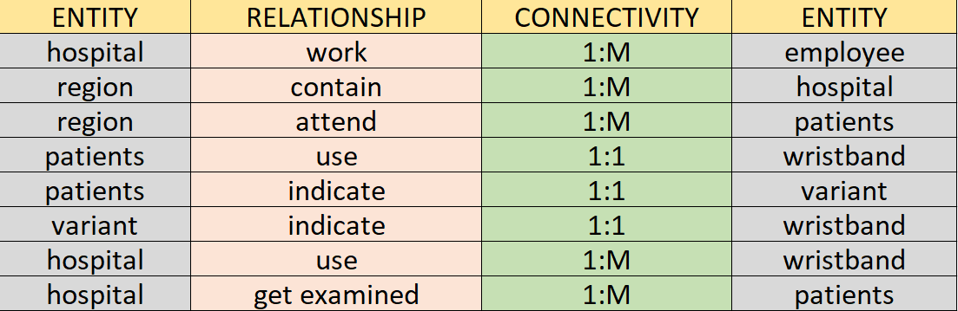

**NF Transformation**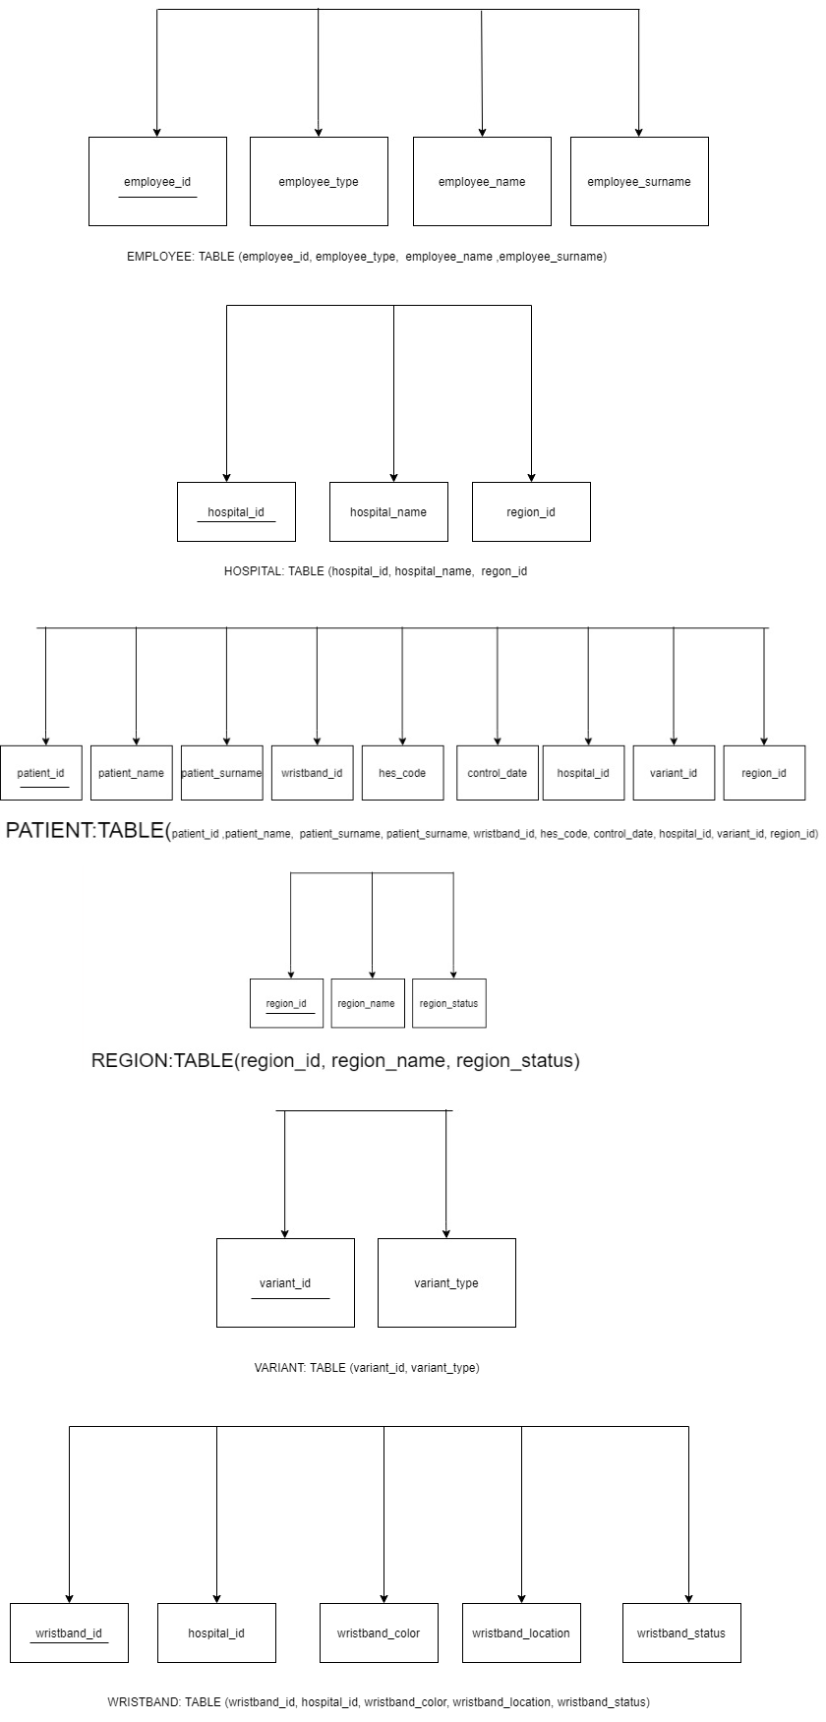

**Table Output Code**

CREATE TABLE REGIONS(

    region_id int Primary Key,

    region_status NVARCHAR(45)

    region_name NVARCHAR(45),

);

SELECT TOP (1000) [region_id]

,[region_status]

,[region_name]

FROM [CovidDb].[dbo].[REGIONS]

-------------------------------------------------------------------------------------------

CREATE TABLE VARIANTS(

    variant_id int Primary Key,

    variant_type NVARCHAR(45)

);

SELECT TOP (1000) [variant_id]

,[variant_type]

FROM [CovidDb].[dbo].[VARIANTS]

CREATE TABLE EMPLOYEES(

    employee_id int Primary Key,

hospital_id int,

    employee_type NVARCHAR(45),

    employee_name NVARCHAR(45),

employee_surname NVARCHAR(45) );

SELECT TOP (1000) [employee_id]

,[employee_type]

,[hospital_id]

,[employee_name]

,[employee_surname]

FROM [CovidDb].[dbo].[EMPLOYEES]

CREATE TABLE HOSPITALS(

    hospital_id int Primary Key,

region_id int,

    hospital_name NVARCHAR(45)

);

SELECT TOP (1000) [hospital_id]

,[region_id]

,[hospital_name]

FROM [CovidDb].[dbo].[HOSPITALS]

CREATE TABLE PATIENTS(

    patient_id int Primary Key,

region_id int,

variant_id int,

hospital_id int,

wristband_id int,

patient_name NVARCHAR(45),

patient_surname NVARCHAR(45),

hes_code NVARCHAR(12),

control_date TIMESTAMP

);

SELECT TOP (1000) [patient_id]

,[variant_id]

,[region_id]

,[hospital_id]

,[patient_name]

,[patient_surname]

,[wristband_id]

,[hes_code]

,[control_date]

FROM [CovidDb].[dbo].[PATIENTS]

CREATE TABLE WRISTBANDS(

    wristband_id int Primary Key,

wristband_color NVARCHAR(45),

    hospital_id int,

wristband_location NVARCHAR(100),

wristband_status NVARCHAR(45),

);

SELECT TOP (1000) [wristband_id]

,[wristband_color]

,[wristband_location]

,[wristband_status]

,[hospital_id]

FROM [CovidDb].[dbo].[WRISTBANDS]

**SQL QUERIES**

**1-)**

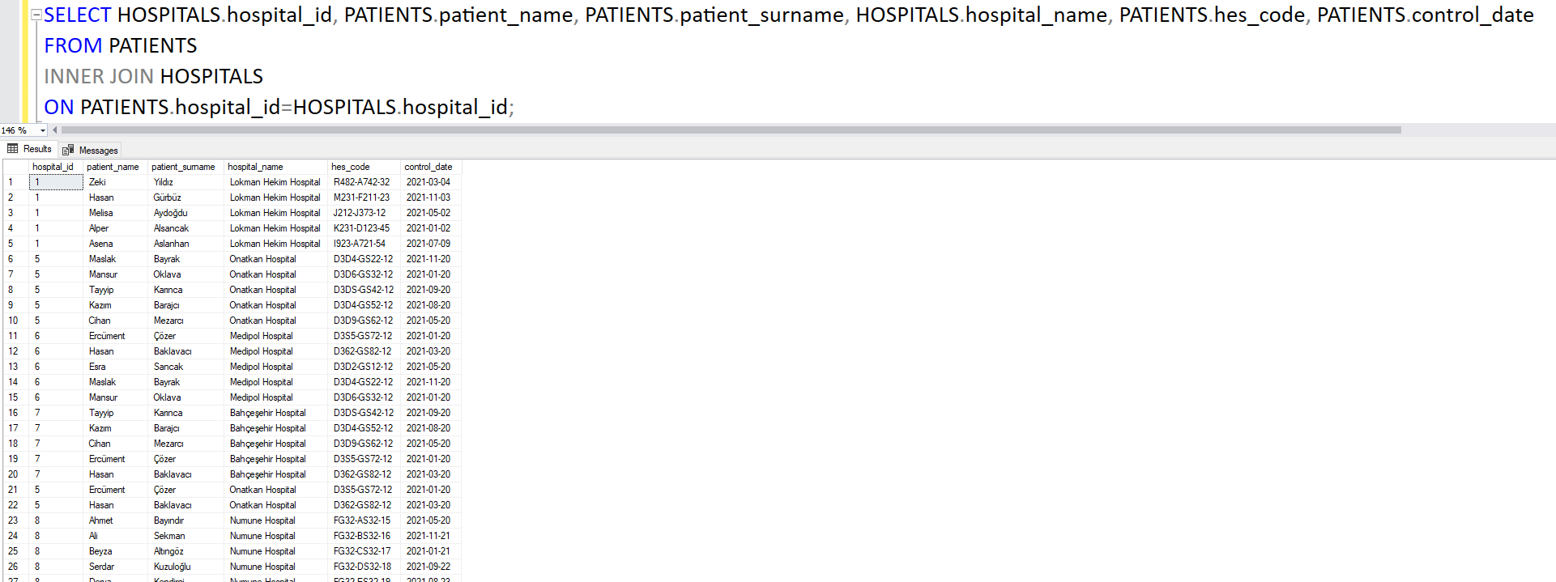

**2-)**



**3-)**

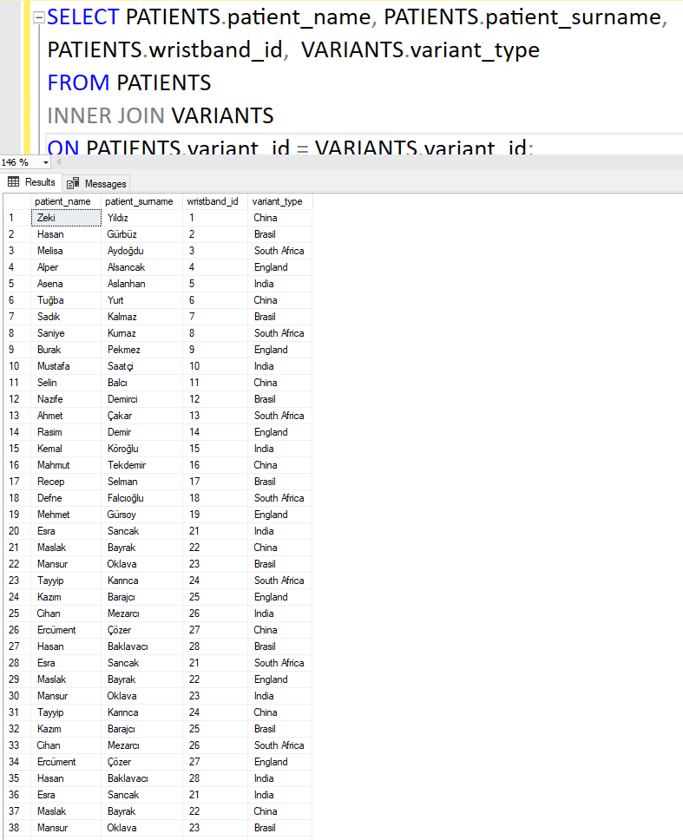

**4-)**



**5-)**

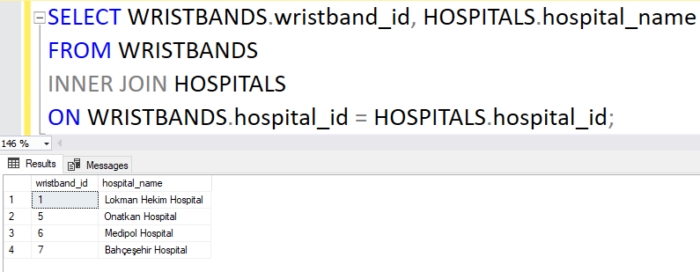

**6-)**

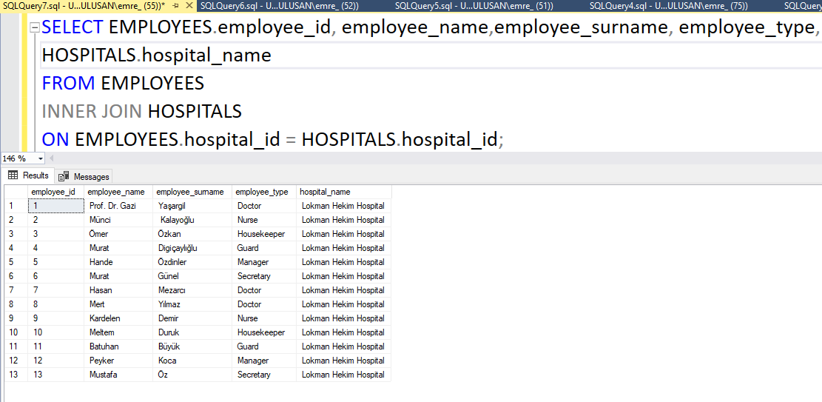

**7-)**

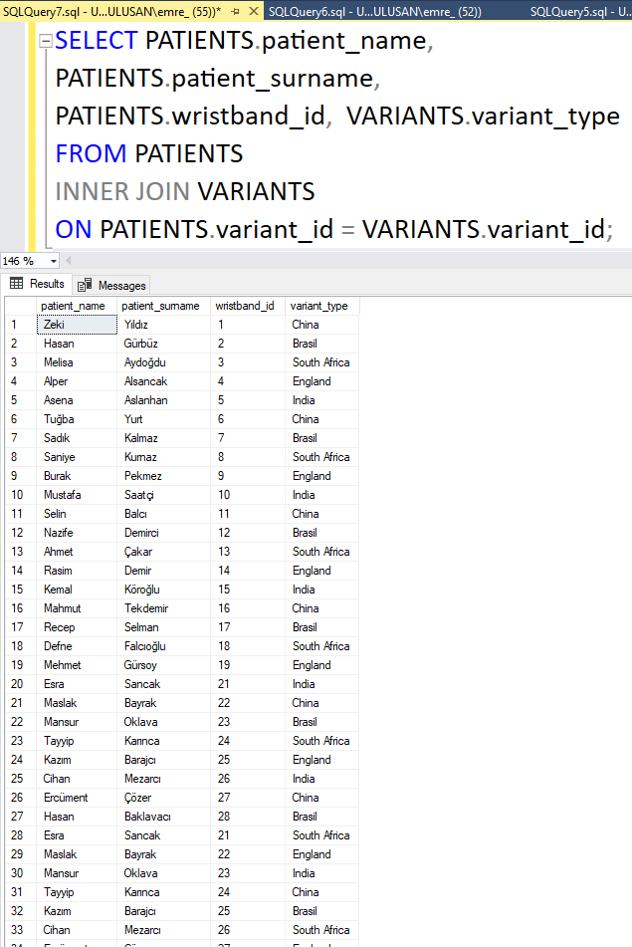

**8-)**

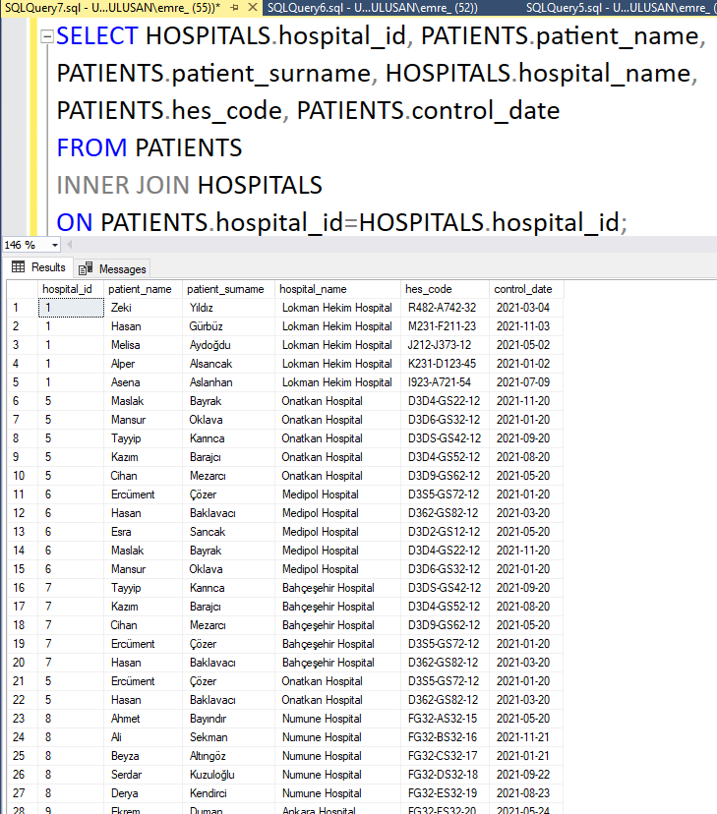

**9-)**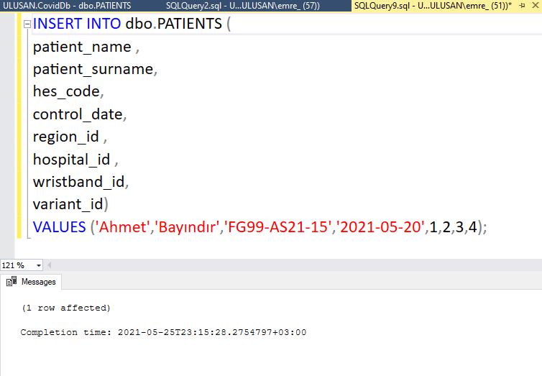

**10-)**

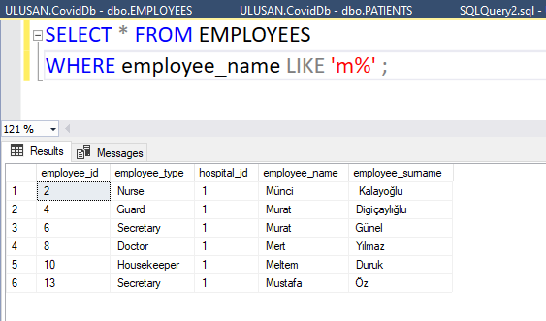

**11-)**

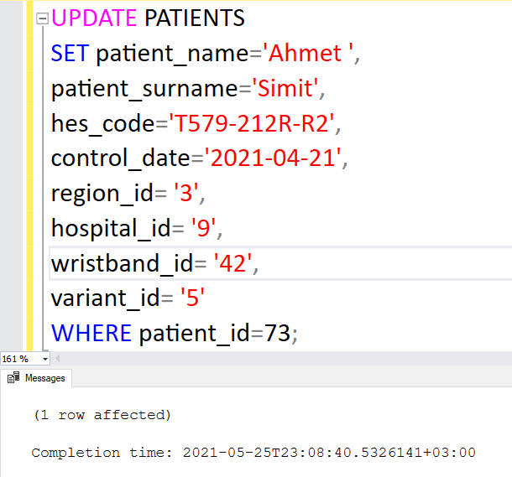

**12-)**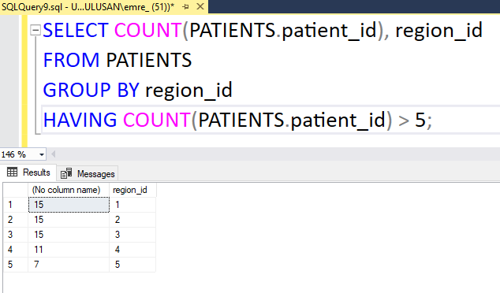

**13-)**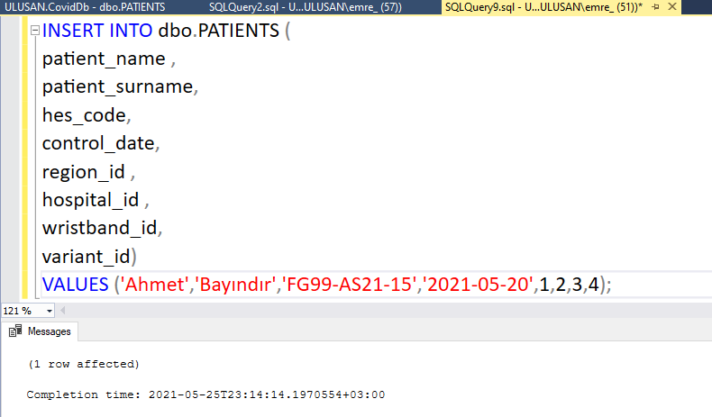

**14-)**

**15-)**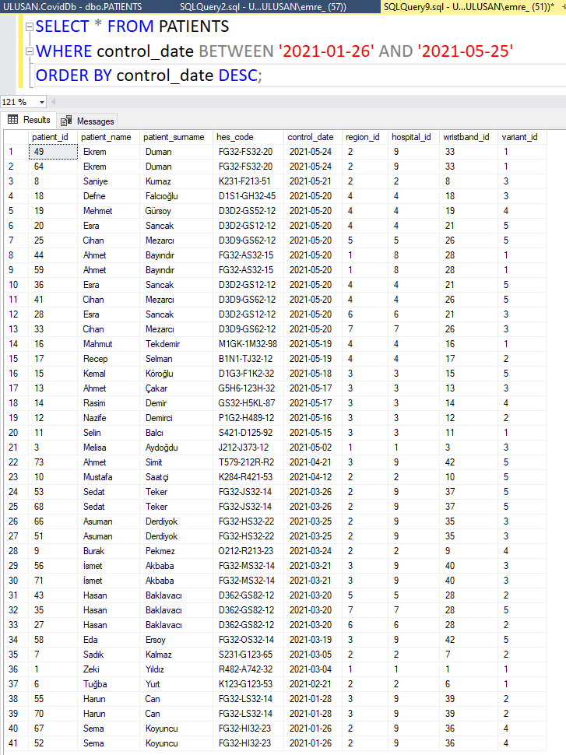

**16-)**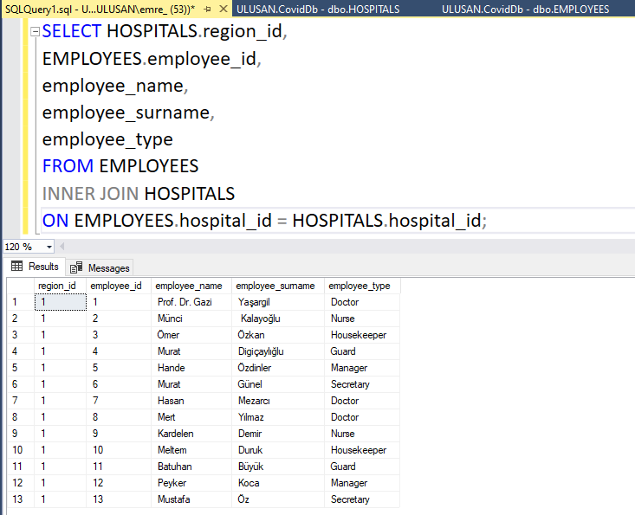

**DATA DICTIONARY**

